|  |  |
| --- | --- |
| **General Information** |  |
| Customer | Lorem Ipsum |
| Created by (Author) | C.T |
| Preparation date | 2/2/2025 |
| Version | 1.0 |
| Status | Pending |

**Revision History**

|  |  |  |  |  |
| --- | --- | --- | --- | --- |
| **Version** | **Description** | **Author** | **Date** | **Approved By** |
| 1.0 | Initial Draft | C.T. | 3/2/2025 | Author: Bossman  Date: 3/2/2025 |
|  |  |  |  |  |
|  |  |  |  |  |
|  |  |  |  |  |
|  |  |  |  |  |
|  |  |  |  |  |

# Introduction

This document describes the methods and procedures used by the PLACEHOLDER CORP team in the functional testing of the [Swag Labs](https://www.saucedemo.com/) online store. It includes the objectives, test

responsibilities, entry and exit criteria, scope, schedule major milestones, deliverables, entry and exit.

The test plan is intended for project managers, product developers, and QA engineers. The objective of the testing activities is to ensure a quality, usable product for the client, Lorem Ipsum.

# Roles and Responsibilities

|  |  |  |
| --- | --- | --- |
| **Name** | **Role** | **Responsibilities** |
| P.M. | Project Manager | * Acts as a primary contact for the development and QA teams. * Responsible for the schedule and overall success of the project. * Co-ordinates with team members to allocate resources. |
| Q.T | QA Lead | * Manages the QA team from a technical perspective. * Plans and organizes the test process for release. * Coordinates with other QA engineers on issues encountered during testing. * Reports progress to the Project Manager. * Proposes best practices and tools for a project. |
| Q.E | QA Engineer | * Puts errors into the QA process and logs them into the bug tracking system. * Writes test cases based on requirements. * Reports and tracks defects. * Performs retesting and regression testing. * Follows the test plan. * Creates test data. * Participate in bug review and other useful meetings. * Coordinate with QA Lead for any issues encountered during test preparation/execution/defect handling |
|  |  |  |
|  |  |  |
|  |  |  |

# Scope

Features of Swag Labs to be tested:

* Login function
* Login validation
* Logout
* Password recovery
* Home screen display
* Add to cart
* Update cart
* Viewing a product
* Product sorting on home screen
* Cart checkout

# Quality Objectives

## Primary

To ensure the Swag Labs product meets the full requirements and satisfies the use case scenarios.

Any updates or deletions to the requirements document, functional specification or design specification will be documented and tested at the highest level/ability of quality allowed, within the remaining project time.

## Secondary

Identify, expose and communicate all issues and risks in the product to the project team. All issues shall be addressed in an appropriate measure before release. Testing should be careful and methodical in order to scrutinize all issues.

# Test Approach

Testing will be conducted in accordance to the requirements-based strategy. Requirements will be sent by clients, which will then be understood by the team.

Test cases and scenarios shall be written based off the requirements, then reviewed by the QA Lead.

Techniques such as:

* Equivalence Class Partition
* Boundary Value Analysis
* Decision Table Testing
* State Transition Testing
* Use Case Testing

…will be used, depending on what is necessary. Test data and test environments will then be setup by the respective QA in charge.

Execution of test cases will be done manually and automated by the respective QA. Techniques such as exploratory, functional, responsive and error guessing testing will be done.

The testing team will report, track and retest defects via an online logging system. All defects will include a title, a summary, environment information, appropriate screenshots/videos and a Pass/Fail status (all to be updated accordingly).

Performance and load testing will be done with automation.

Before each new build of the product, smoke testing will be conducted to ensure various and important functionalities of the application are working. In-depth testing will only proceed after its success. The testing will take place on multiple browsers, screen sizes and environments.

As part of the Testing, we will perform the below types of Testing:

* Smoke Testing and Sanity Testing
* Regression Testing and Retesting
* Usability Testing, Functionality & UI Testing
* User acceptance testing

Test cycles will be repeated until the client is satisfied with the product.

Appropriate manual test cases will be added to the regression automation suite.

The testing team will prepare and share test reports that summarize the testing progress, defect summary and overall progress.

## Defect Life Cycle

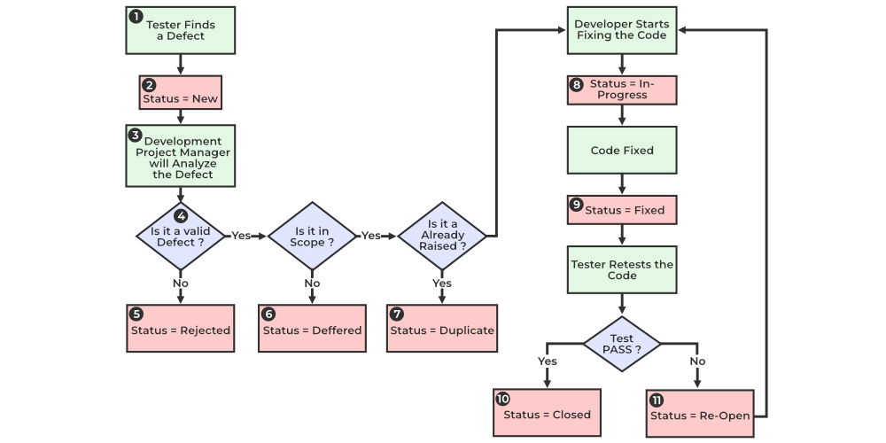

## Defect Severity List

1. Critical: The module/product crashes or the bug causes nonrecoverable conditions. Example: System crashes, GP Faults, or database or file corruption, or potential data loss, program hangs requiring reboot
2. High: Major system component unusable due to failure or incorrect functionality. Example: serious problems such as a lack of functionality, or insufficient or unclear error messages that can have a major impact to the user, prevents other areas of the app from being tested.
3. Medium: Incorrect functionality of component or process. A simple workaround may exist.
4. Minor: Documentation errors or signed off Medium bugs.

All defects must use this severity list.

## Defect Priority List

1. Must Fix: This bug must be fixed immediately; the product cannot ship with this bug
2. Should Fix: These are important problems that should be fixed as soon as possible.
3. Fix When Have Time: The problem should be fixed within the time available. If the bug does not delay shipping date, then fix it.
4. Low Priority: It is not important (at this time) that these bugs be addressed. Fix these bugs after all other bugs have been fixed.

All defects must use this priority list.

## Entry and Exit Criteria

Entry crieria:

* All test environments must have been successfully installed, configured, and functioning properly.
* Proper test data is available.
* Documentation, design, requirements information are available.
* Standard software tools are installed and functioning properly.
* All QA personnel have understood the requirements.
* All QA personnel have sound knowledge of the functionality.
* Test scenarios, test cases and RTM have been reviewed.

Exit Criteria:

* A certain level of requirement coverage has been achieved.
* No high priority of severe bugs are outstanding.
* All high-risk areas have been fully tested, with only minor residual risks left outstanding.
* The testing schedule has been achieved.

## Resources

|  |  |
| --- | --- |
| **Function** | **Name** |
| **Environments** | * Windows XP, 7, 10, 11 * MacOS * Ubuntu * iOS * Android |
| Browser | The latest versions of:   * Chrome * Firefox * Microsoft Edge * Safari   The latest versions of each browser should be tested on each test environment (when available) |
| **Screen sizes:** | Desktop:   * 1920×1080 * 1366×768 * 1440×900 * 1280×720   Mobile:   * 360×800 * 390×844 * 414×896 |
| **Version Control** | **Git** |
| **Hardware** | **Intel i5 processor, 8GB RAM** |
| **Server** | **AWS** |
| **Test case creation** | Microsoft Excel |
| **Test case automation** | Cypress.io + Typescript/Javascript + Jenkins |
| **Defect management** | JIRA |
| **Test reporting** | Adobe Acrobat |
| Project Structure | MindMeister |
|  |  |
|  |  |

## Test Schedule

List the test schedule here:

Following is the test schedule planned for the project –

Task Time Duration

Include the number of sprints.

|  |  |  |  |
| --- | --- | --- | --- |
| **Task** | **Date/Time** | Effort | Comments |
| Creating Test Plan |  |  |  |
| Review of Test Documents |  |  |  |
| First Deploy to Test Environment |  |  |  |
| Test Case Creation |  |  |  |
| Test Case Execution |  |  |  |
| System testing |  |  |  |
| Regression testing |  |  |  |
| User Acceptance Testing |  |  |  |
| Performance Testing |  |  |  |
| Resolution of final defects and final build testing |  |  |  |
| Production Release |  |  |  |
| Summary Reports Submission Date |  |  |  |

## Test Deliverables

.hese are the tangible artifacts and documents generated during the software testing process.

* This document
* Test cases and user scenarios generated
* Test Data
* Test Summary report
* Test closure report
* Incident reports (if any)

## Risks and Mitigations

|  |  |
| --- | --- |
| **Risk** | **Mitigation** |
| Environment not available | Each environment shall have a backup version. All members of the team will be taught to run the product locally. |
| Build URL not working | QA Lead will work with Developers to solve issue. Other members will work on other tasks. |
| Less time for Testing | Project Manager will work with client to identify key areas to be developed and tested. More test team members may be added. |
|  |  |

# Approvals

|  |  |  |
| --- | --- | --- |
|  | **Project Manager** | **QA Lead** |
| **Name** |  |  |
| **Signature** |  |  |
|  |  |  |